Peer Evaluation for Blackjack Application
Your name: (Your lab is the one being evaluated)
Name(s) of peer evaluator(s)
Date:

Instructions
You should have already completed as much of BlackJack as you can given your time constraints. After you and a peer have evaluated your work, you will submit this evaluation along with screen shots and source code indicated in moodle. You may make corrections to your work as a result of the evaluation.
Blackjack GUI Problem
Create a solution that included 3 or 4 projects? (Windows form (blackjack and concentration), class library, console app for testing?) Blackjack GUI is the startup project? Added a using using statement in the blackjack form to access the class library? Added a reference in the gui project to access the class library? | y
Instance variables on the form are objects rather than simple variables (ints, strings)? What are those? | Bjhand, deck, card
Methods are added to the form to do work that is logically complicated that is not handled by a methods in the classes? Those methods pass parameters and return values appropriately? What are those methods? | Loadcard, Loadplayercards, loaddealercards, loadallcards, startgame, computermove, playermove
Additional classes are created to deal with the interaction between classes like the BJHand or Player or Dealer and the UI? What are those? Those classes are added to the class diagram? Screen shot is included? | No extra classes
Does the application function appropriately? Can you interact with the application in a way that causes it to “degrade” and not gracefully? Screen shots are included? | It works (yay) I couldn't get it to break
Source code for the UI is included? Instance variables, methods, classes and event handlers are illustrated? | yes

Programming style for all programs
Is proper indentation used? Is each event handler indented properly? Is each method indented properly? | y
Are comments used appropriately? | y
Do variable names use camel case? (camelCase for example) | y
Do property/method names use Title Case (or Pascal Case?) | y

I couldn't fully remember the ACE chart stuff so hoping this is correc
Action | Control | Event
-Check if Deck is low and needs shuffled  -Create Player and Computer hands from Deck  -Display Hands  -Check if there's a (or more) blackjack – if so announce & restart | New Hand Button | Click
-Deal a card to players hand  -Check if player busted  -Check if computer can move – move if so then check if computer busted | Hit Button | Click
-Make Computer Move until not eligible (over 17 or busted)  -Check if computer Busted  -Check scores and announce winner  -Restart game | Stand Button | Click

SCREENSHOTS
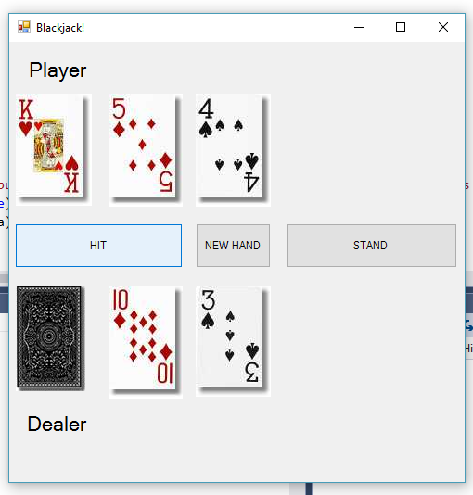
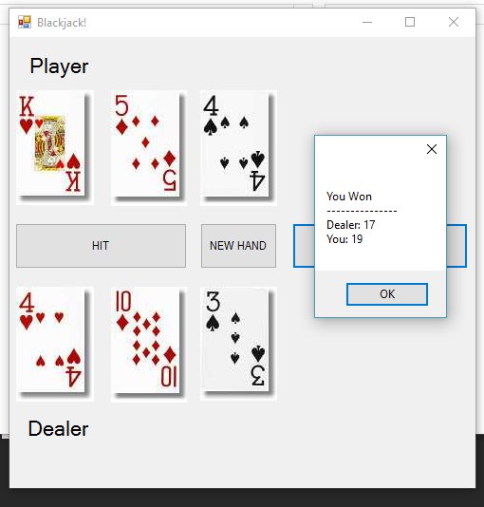
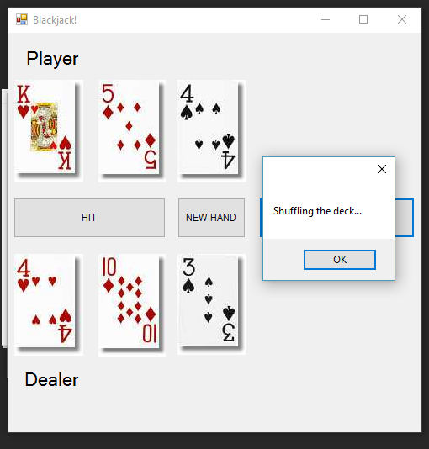
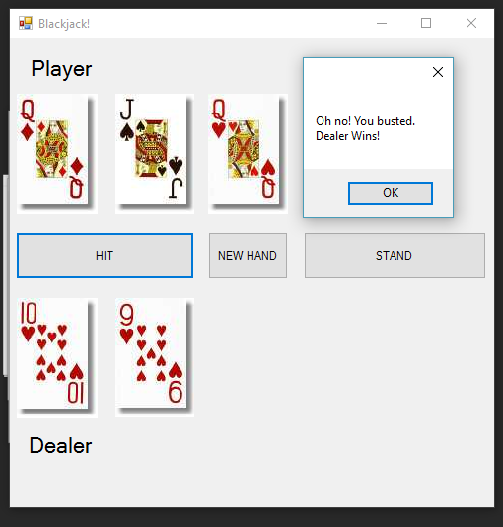
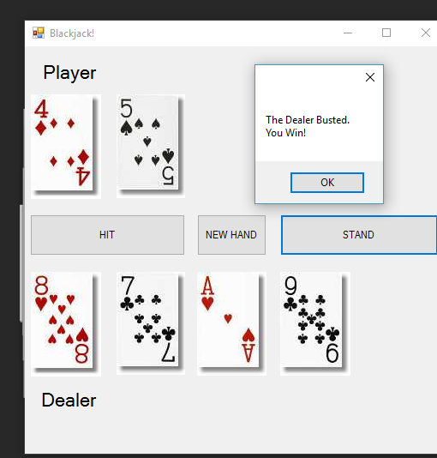
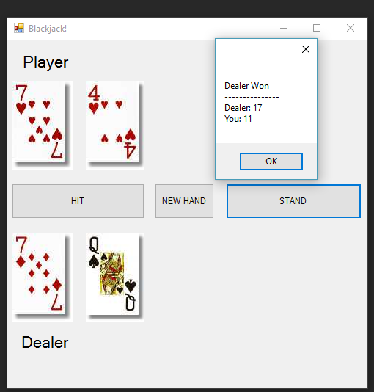

FORM
using System;
using System.Collections.Generic;
using System.ComponentModel;
using System.Data;
using System.Drawing;
using System.Linq;
using System.Text;
using System.Threading.Tasks;
using System.Windows.Forms;
using ClassClassLibrary;

namespace Blackjack
{
public partial class bjForm : Form
{
public bjForm()
{
InitializeComponent();
startGame(true);

}

Deck deck = new Deck();
BJHand playerHand;
BJHand computerHand;

private void hitButton_Click(object sender, EventArgs e)
{
bool bust;
bool dbust;
PlayerMove(out bust);
if (bust) {
LoadAllCards(playerHand, computerHand, true);
MessageBox.Show("Oh no! You busted." + Environment.NewLine + "Dealer Wins!");
startGame(false);
}
else {
LoadPlayerCards(playerHand);
ComputerMove(out canmove, out dbust);
if (dbust)
{
LoadDealerCards(computerHand, true);
MessageBox.Show("The Dealer Busted." + Environment.NewLine + "You Win!");
startGame(false);
}
else LoadDealerCards(computerHand, false);

}
}

private void newHandButton_Click(object sender, EventArgs e)
{
startGame(false);
}

private void standButton_Click(object sender, EventArgs e)
{
bool dbust;
bool canmove = true;
int pScore;
int cpuScore ;

while (canmove)
{
ComputerMove(out canmove, out dbust);
LoadDealerCards(computerHand, false);
if (dbust) { LoadDealerCards(computerHand, true); MessageBox.Show("The Dealer Busted." + Environment.NewLine + "You Win!"); startGame(false); return; }
}
cpuScore = computerHand.Score;
pScore = playerHand.Score;

//dealer can't go and player stood, so calculate winner -- we already checked busting so can just compare raw scores
if (cpuScore > pScore)
{
LoadAllCards(playerHand, computerHand, true);
MessageBox.Show("Dealer Won" + Environment.NewLine + "---------------" + Environment.NewLine + "Dealer: " + cpuScore + Environment.NewLine + "You: " + pScore);
startGame(false);
}
else if (cpuScore < pScore)
{
LoadAllCards(playerHand, computerHand, true);
MessageBox.Show("You Won" + Environment.NewLine + "---------------" + Environment.NewLine + "Dealer: " + cpuScore + Environment.NewLine + "You: " + pScore);
startGame(false);
}
else
{
LoadAllCards(playerHand, computerHand, true);
MessageBox.Show("Push" + Environment.NewLine + "---------------" + Environment.NewLine + "Dealer: " + cpuScore + Environment.NewLine + "You: " + pScore);
startGame(false);
}
}

private void startGame(bool newDeck)
{
//option for starting from a new deck, or if new deck has less than possibly playable cards
if (newDeck == true || deck.NumCards < 10)
{
deck = new Deck();
deck.Shuffle();
MessageBox.Show("Shuffling the deck...");
}

//build new hands for player and computer
playerHand = new BJHand();
computerHand = new BJHand();
Card c1;
Card c2;
string extra = "!";
for (int i = 0; i < 2; i++)
{
c1 = deck.Deal();
playerHand.Add(c1);
c2 = deck.Deal();
computerHand.Add(c2);
}

//load hands in UI
LoadAllCards(playerHand, computerHand, false);
if (playerHand.Score == 21) {
if (computerHand.Score == 21) extra = " ..but so did the dealer." + Environment.NewLine + "The game is a tie!";
LoadAllCards(playerHand, computerHand, true);
MessageBox.Show("You got a Blackjack"+extra); startGame(false);
}
else if (computerHand.Score == 21) {
if (playerHand.Score == 21) extra = " ..but so did the dealer." + Environment.NewLine + "The game is a tie!";
LoadAllCards(playerHand, computerHand, true);
MessageBox.Show("The dealer got a Blackjack"+extra); startGame(false);
}

}

public void PlayerMove(out bool bust)
{
Card c = deck.Deal();
playerHand.Add(c);
LoadPlayerCards(playerHand);
if (playerHand.Score > 21) { bust = true; }
else bust = false;
}

public void ComputerMove(out bool canmove, out bool bust)
{
//computer stands on 17 or greater, hits on less than 17 unless ace is present - hits on 17
int score = computerHand.Score;
canmove = true;
if (score < 17 || (score == 17 && computerHand.HasAce()))
{
Card c = deck.Deal();
computerHand.Add(c);
}
else canmove = false;
LoadDealerCards(computerHand, false);
if (computerHand.Score > 21) bust = true;
else bust = false;
}

//event handlers for bust, blackjack, and shuffle

//CardLoading methods, LoadAllCards will redraw the card elements
#region CardLoading

private void LoadAllCards(BJHand playerHand, BJHand dealerHand, bool end)
{
LoadPlayerCards(playerHand);
LoadDealerCards(dealerHand, end);
}

private void LoadPlayerCards(BJHand h)
{
int i = 0;
//load cards, probably would have made more sense to use a for loop since I'm going to 5 anyway, oh well
foreach(Card c in h)
{
LoadCard(c, "p", i++);
}
//hide the missing cards
for (int z = i; z < 5; z++)
{
PictureBox box = (PictureBox)this.Controls["pcard" + z];
box.Visible = false;

}
}

private void LoadDealerCards(BJHand h, bool turnfirst)
{
int i = 0;
//load cards
foreach (Card c in h)
{
if (i == 0 && turnfirst == false)
{
PictureBox box = (PictureBox)this.Controls["dcard0"];
box.Image = Image.FromFile(System.Environment.CurrentDirectory + "\\Cards\\black_back.jpg");
i++;
}
else LoadCard(c, "d", i++);
}
//hide rest
for (int z = i; z < 5; z++)
{
PictureBox box = (PictureBox)this.Controls["dcard"+z];
box.Visible = false;

}

}

private void LoadCard(Card card, string player, int i)
{
PictureBox box = (PictureBox)this.Controls[player + "card" + i];
box.Image = Image.FromFile(System.Environment.CurrentDirectory + "\\Cards\\" + card.FileName);
box.Visible = true;
}
#endregion

}
}

